Real Property Holdings Owned by the Hospital (HB 321)

Location | Parcel ID Number | Estimated Size | Purchase Price | Current HealthCare Purpose? |  | Improvements? |  | Notes  (Optional)
 |  |  |  | Yes | No | Yes | No
Date: _______________.
Revised: ________________.

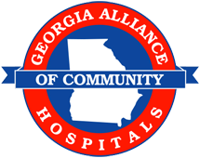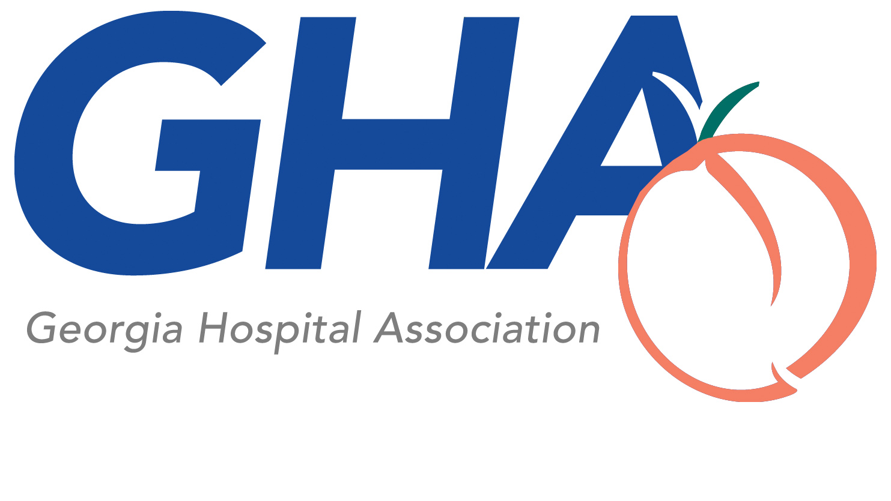

Location may be the county, address, or site identification/description.
Purchase price to be listed as of the date of acquisition of the property by the hospital, if known. If unknown, state “UNK”.
Health care purpose includes the provision of patient care; the provision or delivery of healthcare services, including supportive administrative services; the training and education of physicians, nurses, and other healthcare personnel; and community education and outreach relating to health care or wellness.
Improvement means the permanent addition or construction of a building or structure.

