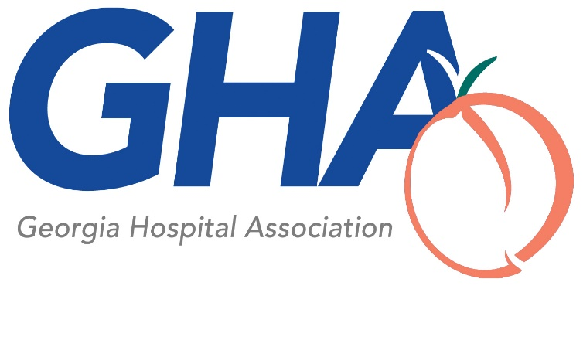

Transparency Completeness Checklist (HB 321 & HB 186)
Prepared by the Georgia Alliance of Community Hospitals and Georgia Hospital Association
HB 321 Document/List/Report Required: | General Instructions: | Special Requirements: |  |  | Date Posted:
Audited Financial Statements – Hospital | Most recent version (.pdf) | Contain HB 321 required note (gross patient revenue, allowances, charity care, and net patient revenue?*
 |  | Yes | No
Alternative: Consolidated Financial Statements Including Hospital | Most recent version (.pdf) | List entities included?
 |  | Yes | No
Combining or Consolidating Schedules/Financial Information break out for Hospital Subsidiaries | Required for hospitals with subsidiaries and consolidating financial statements. Have balance sheet, statement of operations, or statement of net position? | Contain GAAS required report?*
 |  | Yes | No
Audited Financial Statements – Hospital Parent Company | Most recent version (.pdf). Only post for a Georgia entity that directly owns or controls the entity that operates the hospital.
Combining or Consolidating Schedules/Financial Information break out for Hospital & Brother/Sister Co. | Required for hospitals with parent company and consolidating financial statements. Have balance sheet, statement of operations, or statement of net position? | Contain GAAS required report?*
 |  | Yes | No
Audited Financial Statements – Hospital Subsidiaries | Most recent version (.pdf). Only post for entities directly owned and controlled by the entity that operates the hospital. Do not post audited financial statements for subsidiaries that were inactive or where total assets of subsidiary constitute < 20% of the total assets of the entity that operates the hospital. If subsidiary does not have financial statements per GAAP, state “N/A”
IRS Form 990 | As filed with IRS, including Schedule H, but exclude Schedule B. May be individual or consolidated. | Post copies of Schedule H and other filed Schedules (except Schedule B)?
 |  | Yes |  | No
Alternative IRS Form 990 (if available from DCH) | Form not yet available from DCH.
AHQ | As filed with DCH.
Community Benefit Report | As filed with Superior Court Clerk. If none required under O.C.G.A. §31-7-90.1, state “N/A”
Medicaid DSH Survey | If not required, state “N/A”
(NEW) List of Real Property Holdings Owned by Hospital  Note: Reconcile with Form 990 (Part X and Schedule D, Part IV – high level listing of land and buildings as assets) | GACH/GHA template available if required information not contained in existing report. Do not include leased property.
(NEW) List of Hospital JVs and Ownership Interests  Note: Reconcile with Form 990 (Part VI, Section B – JV with taxable entity, Schedule H, Part IV – JV with certain persons, and Schedule R - % ownership). | GACH/GHA template available if required information not contained in audited financial statement or existing report. If contained in financial statements, state “F/S” and indicate page or section reference.
(NEW) Listing of Hospital Indebtedness  Note: Reconcile with Form 990 (Part IV/Schedule K – tax exempt bonds and Part X/Schedule L – loans with interested persons)  Note: Reconcile with CON Applications recently filed (Question 26 – existing indebtedness) | GACH/GHA template available if required information not contained in audited financial statements or existing report. If contained in financial statements, state “F/S” and indicate page or section reference. | Include names of any bond disclosure sites to which hospital submitted info?
 |  | Yes |  | No
(NEW) Report of End of Year Net Assets | GACH/GHA template available if required information not contained in audited financial statements. If contained in financial statements, state “F/S” and indicate page or section reference. | Included for hospital, parent, subsidiaries, and foundation controlled or owned by hospital or parent?
 |  | Yes |  | No
Copy of any “going concern” note in Hospital Financial Statements | Provide reference (page or section) to portion of financial statements containing note.
Alternative: Statement that there is no going concern disclosure in the hospital’s audited financial statements
(NEW) Dated Organizational Chart |  | Includes hospital, parent, subsidiaries and brother/sister companies?
 |  | Yes |  | No
(NEW) Compensation/Benefits Report  Note: Reconcile with Form 990 (Part VII, Section A & Schedule J (Part II)) | Template available if required information not contained in Form 990. List positions, not names.
Evidence of Hospital Accreditation (e.g., the Joint Commission or DNV) | Copy of certificate or accreditation decision award letter
Indigent and Charity Care Policy
Debt Collection Policy
HB 186 Documents Required: | General Instructions: | Special Requirements: |  |  | Date Posted:
Hospital Financial Survey
Any ASC Surveys Filed by Hospital
Any Imaging Center Surveys Filed by Hospital
* GHA and GACH advised DCH that these notes/reports likely would be contained only in audited financial statements prepared and finalized after July 1, 2019 (i.e. the effective date of HB 321) based on definitions of key terms.
Date: July 22, 2019

