Hello Future Students and Parents!

Students can APPLY NOW for Scholarships, Bursaries, and Entrance Awards
Did you know that TRU offers over $5 million in scholarships, bursaries, and awards each year to both new and returning students? Applying is simple, and with just one application, students are automatically considered for all eligible funding.
Learn More
Brief overview:
General Undergraduate Entrance Scholarships:  up to $30,000 per scholarship | Recognizes academic excellence, leadership, service and accomplishments that foster TRU's values. | Deadline:  March 1
TRU Undergraduate Entrance Awards:  up to $4,000 per award | Recognizes leadership, service and accomplishments that foster TRU's values, with preference to first generation university students. | Deadline:  April 1
TRU Assurance Bursary:  up to $20,000 per bursary | For new and returning bachelor’s degree students, with preference to students enrolled in open programs, and/or from the TRU region. | Deadline:  May 31
TRU Undergraduate Entrance Bursary:  up to $4,000 per bursary | For new, full-time, diploma or degree students facing financial hardship. | Deadline:  May 31
Note: Should students have any queries regarding their eligibility or application, they can reach out directly to studentawards@tru.ca or
Join our virtual information session, "Application 101 - Scholarships and Awards", to receive support for their application.
Date: 24 January
Time: 4:30 PM
Register Link

Applications are OPEN at TRU
You can apply to TRU through EPBC. All applications are recommended to apply before May 1 for the fall 2024 term. Application deadlines of note are:
- Bachelor of Science in Nursing: January 31, 2024
- Respiratory Therapy: February 1, 2024
- Veterinary Technology: February 1, 2024
Apply Now
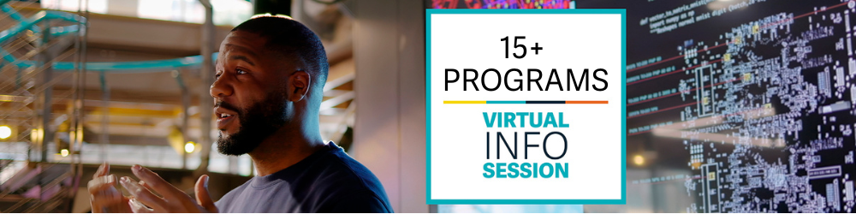
Program Information Sessions
In the changing world of education, attending Program Info Sessions is not just an option; it's a strategic move that can significantly impact your academic journey and future career. These sessions provide valuable insights, guidance, and a wealth of information that can shape your decisions and set you on the right path.
Explore the upcoming TRU virtual program info sessions to register: www.tru.ca/infosessions

Discover TRU - Virtual and In Person Sessions
For students thinking about applying for an undergraduate program at TRU. Join us online to learn what it’s like to be a TRU student while we uncover the top 10 reasons to choose TRU. (Including how to apply!)
Date: 12 December
Time: 6:00 PM
Register Link

Application 101: Scholarship & Awards Virtual Info Session
The TRU Future Students Office and Student Awards and Financial Aid will be online to review the scholarship and awards application process. Join us to discover tips and tricks you need for your application.
Topics covered are:
- Why you should apply
- What you should apply for
- How to apply
- How to write a strong essay (the do's and don'ts!)
- Review of a scholarship winner
Date: 24 January
Time: 4:30 PM
Register Link

Parent Information Nights
Are you a parent or guardian of a current or recent high school student who is exploring post-secondary? They will probably look to you for guidance as they navigate the transition to university, so we're here to help! Join the Future Students Team to learn about TRU, ask questions, and gain the knowledge and resources to support your future post-secondary student.
Date: 7 December
Time: 7:00 PM
Register Link

NEW PROGRAM: Bachelor of Engineering in Computer Engineering
We're thrilled to share some exciting news with you - applications for our brand-new Bachelor of Engineering in Computer Engineering program are now open! In this five-year program, students will learn to design cutting-edge hardware systems, develop software solutions and optimize computer networks. This program is truly where design meets technology in the most exciting way. Did you know the average salary in Canada for computer engineers was $94,575 in 2023?
TRU’s first intake is September 2024.
Explore the program

Associate of Commerce and Business Administration
If you’re uncertain about your educational commitment, you can apply for our open admission Associate Business Program. This diploma is designed to acknowledge the achievements of those facing financial, family, work, or academic constraints preventing the completion of a full four-year business degree. You can later return to TRU to complete the Bachelor of Business Administration.
Explore the program

Contact Information
TRU Future Students Team is available to connect with you through a number of platforms:
- Ask Us a Question (students) by emailing futurestudents@tru.ca .
- Booking an appointment with a Future Student Advisor.
- Live Chat on the Future Students page. Student Advisors are available to chat between 9 am - 4 pm Monday to Friday.
- Phone 250-828-5006

