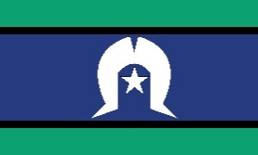
Resources and Events Update
The Bulletin

May 2023 Issue

EDUCATION AND ADOPTION

DIGITAL HEALTH – Did you know?

My Health Record and patient privacy

Privacy awareness week occurs on 1 – 7 May 2023 and is an annual event to raise awareness of privacy issues and the importance of protecting personal information.
My Health Record is a safe and secure system, designed to support better health care and has a number of privacy features. It can be reassuring for patients to be informed that it is only doctors or other authorised staff working in a My Health Record registered practice that are able to access a patient’s My Health Record and it must be for the purpose of providing healthcare to a patient.

DIGITAL HEALTH - WEBINARS

Patients can also put access controls on their My Health Record if they wish. These controls can be applied to their entire My Health Record or specific documents as they see fit. Patients can also opt to receive SMS notifications, for example when their record has been accessed by a new healthcare organisation.

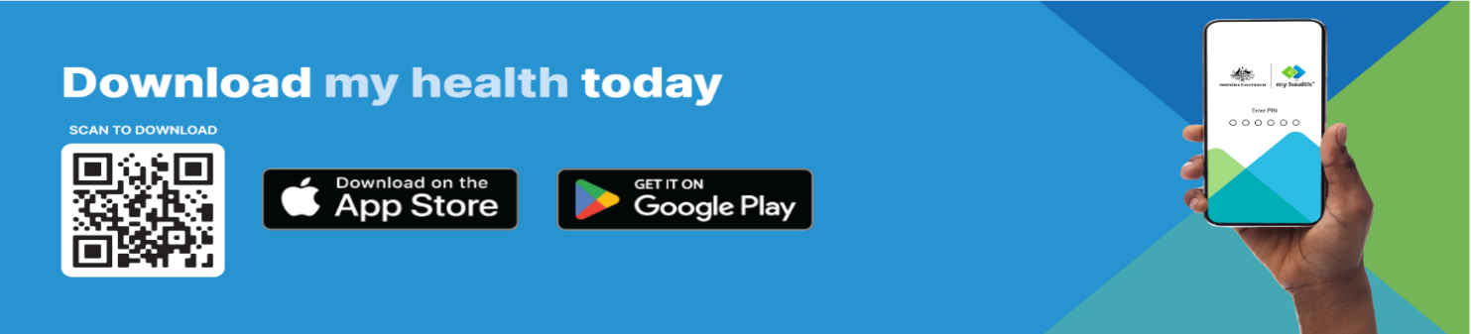
Learn more
- To learn more about My Health Record and patient privacy join one of the Agency’s FREE webinar sessions

- For further information about privacy and access in your practice visit the Agency’s website

As part of the Agency’s Consumer Digital Health Literacy program, we are increasing our offering of webinars to consumers on a range of digital health topics. This includes My Health Record, my health app, electronic prescriptions as well as collaborations with a number of Community Peak and Partner Organisations. We would encourage to please advertise and share these sessions with your consumer networks. Upcoming sessions are highlighted below and are also available here
CONSUMER WEBINARS

The new my health app – secure and convenient way to access My Health Record
The new my health app lets you view and download key health information that you, your healthcare providers or representatives have uploaded to My Health Record. It’s fast, easy, and secure - and you can access and share it all from the palm of your hand.
- Date: 8 June 2023
- Time: 12.30 – 1.00pm AEST
- Register here
My Health Record for carers
Carers play an important role in managing the health information of the person they are caring for. Join this session to find out more how carers can access and manage My Health Record of an individual. This session will cover the role of authorised and nominated representatives. There will also be an opportunity for question and answer time at the end.
- Date: 23 May 2023
- Time: 12:30- 1:00pm AEST
- Register here

Understanding your heart health with the Heart Foundation and My Health Record
This session will equip you with the knowledge to better understand your personal risk of heart disease and manage your heart health information with My Health Record. You will learn the three simple steps that you can take to keep your heart healthy, as well as how and where you can access Heart Health Checks with your healthcare provider. The webinar will also cover topics such as how to access your My Health Record and my health app, including medicines information and heart-related test results such as pathology and INR reports. You will have an opportunity to have your questions answered by the speakers during the Q&A session at the end of the webinar.
- Date: 4 May 2023
- Time: 1:00 – 2.00pm AEST
- Register here
How can I upload information in My Health Record?
My Health Record is a personally controlled record which means individuals can manage information in their record and upload health information such as medicines, allergies or advance care planning. Join this session to find out more about what information you can upload to your My Health Record and also who can view that information. There will also be an opportunity for question and answer time at the end.

- Date: 10 May 2023
- Time: 12:30- 1:00pm AEST
- Register here

How can I view test results or scans in My Health Record?
Would you like to know more about how to access your pathology and diagnostic imaging test results in your My Health Record? Join our webinar to hear more about the range of registered pathology laboratories and diagnostic imaging services upload test results and scans to My Health Record. You will also learn more detail around when your test results will be available and where to find them. There will also be an opportunity for question and answer time at the end.
- Date: 17 May 2023
- Time: 12:30- 1:00pm AEST
- Register here

MAY  3 | Digital Health Yarning  1:00 – 1:20pm AEST  Weekly yarn on a variety of Digital Health topics  Audience: Aboriginal and Torres Strait Islander Health Service staff  Join Here |  | MAY  4 | My Health Record for Health workers – Series 3  12:30-1:00pm AEST  Learn how Digital health can help our mob.  Audience: Aboriginal and Torres Strait Islander Health Service staff  Register
MAY  5 | Improving data quality in your practice – Diabetes Quality Improvement  11am – 11:30am AEST  Learn how to improve your practice’s data quality.  Audience: All healthcare organisations  Register |  | MAY  09 | Digital health Foundations - #1 Healthcare Identifiers and the HI service  2:30pm – 3:00pm AEST  Learn how to connect to digital health services.  Audience: All healthcare organisations  Register
UPCOMING EVENTS
MAY  10 | Digital Health Yarning  1:00 – 1:20pm AEST  Weekly yarn on a variety of Digital Health topics  Audience: Aboriginal and Torres Strait Islander Health Service staff  Join Here |  | MAY  16 | Digital Health Foundations - #2 Accessing PRODA & HPOS  11am – 11:30am AEST  Learn how to connect to digital health services.  Audience: All healthcare organisations  Register
MAY  16 | My Health Record for Health workers – Series 3  12:30 – 1:00pm AEST  Learn how Digital health can help our mob.  Audience: Aboriginal and Torres Strait Islander Health Service staff  Register |  | MAY  17 | Understanding My Health Record and patient privacy  1:00 – 1:30pm AEST  Learn how patients can control access to their My Health Record  Audience: All healthcare organisations  Register
MAY  17 | Digital Health Yarning  1:00 – 1:20pm AEST  Weekly yarn on a variety of Digital Health topics  Audience: Aboriginal and Torres Strait Islander Health Service staff  Join Here |  | MAY  18 | Digital Health Foundations - #3 Registering a Seed Organisation with the HI service  1:00pm to 1:30pm AEST  Learn how to connect to digital health services.  Audience: All healthcare organisations  Register
MAY  18 | My Health Record for Health Workers - Series four  12:30p – 1:00pm AEST  Learn how to access My Health Record  Audience: Audience: Aboriginal and Torres Strait Islander Health Service staff  Register |  | MAY  24 | Digital Health Yarning  1:00 – 1:20pm AEST  Weekly yarn on a variety of Digital Health topics  Audience: Aboriginal and Torres Strait Islander Health Service staff  Join Here
Keep up to date:
- With a full range of webinar topics for consumers and health care providers visit the Agency’s website

- For further information and support in relation to education and training, email the team: William.Namok@digitalhealth.gov.au or Nakkari.Smith@digitalhealth.gov.au

